**What is WEB (World Wide Web or W3)?**

* World Wide Web (w3 or Web) is a collection of websites or web pages stored in web servers and connected to local computers through the internet.

**What is Webpage?**

* A web page is a document on the World Wide Web "with its own address".
* Web pages are delivered by a web server to the user and displayed in a web browser.

**What is Website?**

* A website consists of many web pages linked together under a common domain name.

**Types of Websites?**

There are two fundamental types of websites:

1. static websites

* A static website that displays the same content to all visitors in the same format.

1. dynamic websites

* A dynamic website presents different information to different visitors.
* The dynamic websites are also called web applications

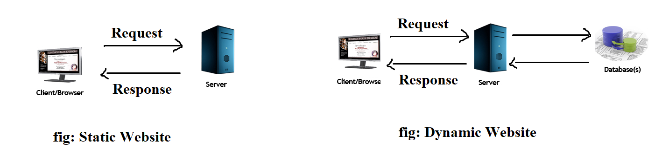

**History of the World Wide Web:**

* The World Wide Web was invented by a British scientist, Tim Berners-Lee in 1989.

**What is webserver?**

* A web server is a software program which serves the web pages requested by web users using a browser.
* All the websites are stored in web servers.

**How the World Wide Web Works?**

* The Web works as per the internet's basic client-server format.
* The servers store and transfer web pages or information to user's computers on the network when requested by the users.

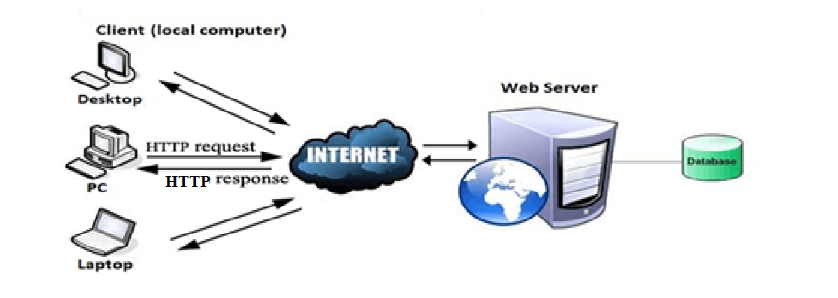

**Hypertext Transfer Protocol (HTTP):**

* Hyper Text Transfer Protocol (HTTP) is an application layer protocol (it is web protocol) which enables the communication between client and server.
* It is based on a client-server model.
* The client is a web browser which communicates with the web server which hosts the website.

**What is Search Engine?**

* The Search engine is a program which is designed to enable the users to browse information or content on World Wide Web.
* The most popular search engines are Google, Bing, and Yahoo! Search.

**What is HTML?**

* HTML (HyperText Mark-up Language), it is a computer language used for the creation of webpages.
* It defines how the web page looks and how to display content with the help of elements.
* HTML describes how a document should be displayed by an internet browser.
* HyperText stands for Link between web pages.
* Mark-up Language means Text between tags that define the structure.
* Each HTML page consists of a sequence of HTML elements, where each element consists of a collection of sequential tags and attributes. A tag represents the start and end of an HTML element, while an attribute specifies its characteristics.
* These elements are used to mark up the content of the webpage, such as headings, paragraphs, lists, images, links, forms,….,etc.,
* We can save the html file with .html or .htm extension

**History of HTML:**

* Tim Berners-Lee, a physicist at the CERN research institute in Switzerland invented HTML in 1991.
* in the year of 1991,the Tim Berners-Lee invents HTML1.0
* The HTML 2.0 is released in the year of 1995.
* The HTML 3.0 is released in the year of 1997.
* The HTML 4.0 is released in the year of 1999.
* The HTML 5.0 is released in the year of 2014.
* This first version consisted of 18 HTML tages. Now, there are currently about 140 HTML tags.

**What is HTML Element?**

* HTML documents are composed of HTML elements.
* An HTML element is a component of an HTML document, it contain content (such as text or an image) along with HTML tags, that tell the browser how to interpret the content (such as a heading or paragraph text).
* HTML elements can be used to add structure, semantics, and formatting to different parts of an HTML document.

**Types of HTML Elements:**

The HTML Elements can be categorized into 2-types they are,

1. inline-level Elements
2. block-level Elements

**Inline-level elements:**

* The inline-level elements are mainly in the contents of a block.
* In addition to that, their width is based on how much space that individual element needs.
* Ex: <img>, <a>, <span>, <strong>, <b>, <em>, <i>, <code>, <input> and <button> ,…etc.

**Block-level elements:**

* The block-level elements make up the structure of the document.
* It takes up the entire width of the page.
* Ex: <div>, <p>, <h1>, <h6>, <form>, <ol>, <ul> and <li>, ….,etc.,

**What is HTML Tag?**

* An HTML tag is a piece of markup language used to indicate the beginning and end of an HTML element in an HTML document.
* HTML tags are like keywords which define that how web browser will format and display the content.
* As part of an HTML element, HTML tags help web browsers convert HTML documents into web pages.
* They consist of an opening bracket(<),followed by the name of the element and then a closing bracket(>)
* Syntax: <tag> content </tag>

**Types of tags:**

There are two kinds of HTML tags,

* Paired : it requires both opening tag and closing tag
* Unpaired : don’t required closing tag

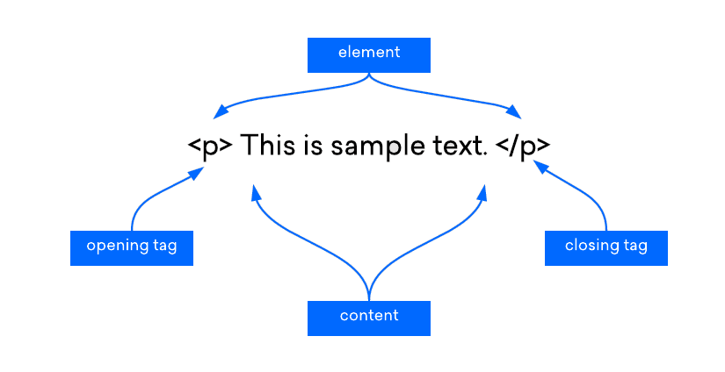

**What is HTML Attribute?**

* An HTML attribute is a piece of mark-up language used to adjust the behaviour or display of an HTML element.
* For example, attributes can be used to change the color, size, or functionality of HTML elements.
* Syntax: <tag_name attribute_name="value"> Content </tag_name>

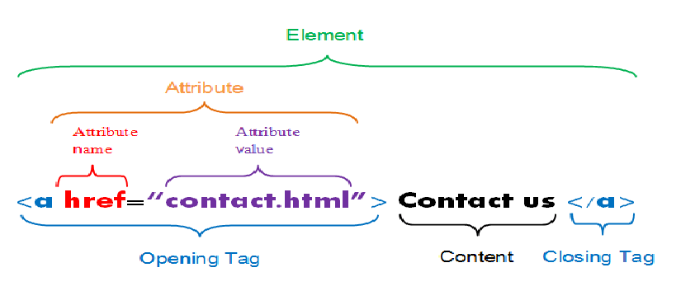

**Basic structure of an HTML document:**

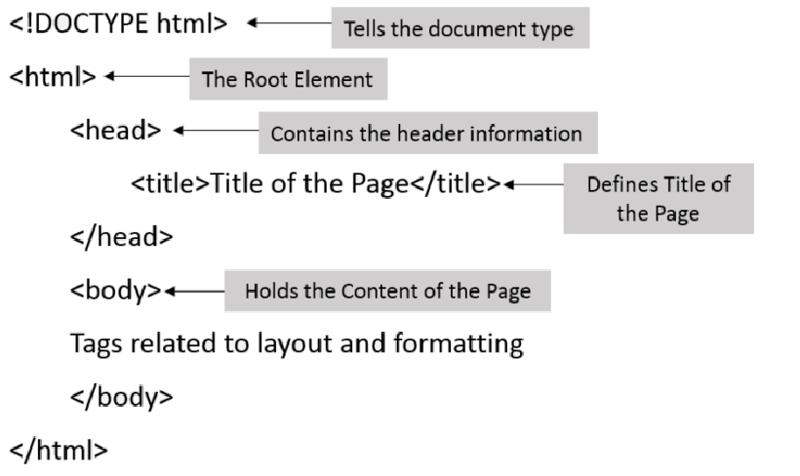

The basic structure of an HTML document consists of 5 elements:

1. <!DOCTYPE>
2. <html >
3. <head>
4. <title>
5. <body>

**The DOCTYPE**

* A DOCTYPE declaration must be specified on the first line of each web document.
* The DOCTYPE tells the web browser which version of HTML the page is written in.

**The <html> Element**

* Immediately following the DOCTYPE declaration is the <html> element.
* The <html> element tells the browser that the page will be formatted in HTML and, optionally, which world language the page content is in.

**The <head> Element**

* The <head> element surrounds all the special “behind the scenes” elements of a web document. Most of these elements do not get displayed directly on the web page.

**The <title> Element**

* The <title> element defines what text will show in the web browser’s title bar.

**The <body> Element**

The <body> element surrounds all the actual content (text, images, videos, links, etc.) that will be displayed on our web page.

**How to write the html programs?**

1. Open Any one Editor (or) IDE in your PC and type the following code:

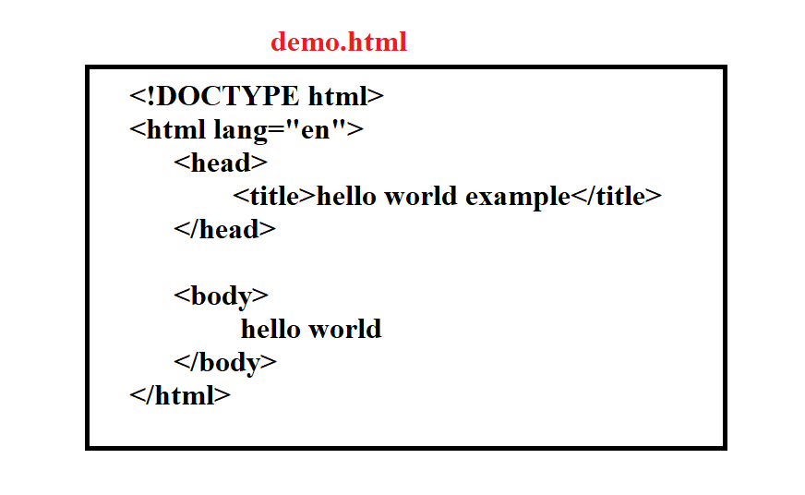

1. Once done, save your file with any name of your choice but give the extension as ".html", This converts your file in to a web page.
2. The last step is to go the location where you saved your file. Did you observe its icon? It will be the icon of your default browser. Just Double-click it to open and it will open in your default browser.

**Note:** HTML is case-insensitive. It means that you can enter the tags in both uppercase as well lowercase. It doesn’t matter!

**Features of HTML:**

* Easy to learn and use
* Easy to code
* Platform independency
* Easy to embed various elements like images, links, videos, audios,…,etc.,

**Advantages of HTML:**

* **Beginner-friendly**: HTML has a shallow learning curve, making it friendly even for absolute beginners.
* **Accessible:** It is an open-source and freely available language. Also, it runs on every modern browser.
* **Flexible:** HTML is known for its flexibility as it can seamlessly integrate with JavaScript and other backend languages, such as Python, Java, PHP.
* **Support:**As the language is extremely popular, you can find comprehensive documentation and a plethora of resources available on the web.

**Drawbacks/Disadvantages of HTML:**

* **Static:** With HTML, you can only create static web pages. To make web pages dynamic, you need to use JavaScript/PHP/Python/Java .
* **Browser Compatibility:** Many times, you may encounter a problem where some browsers take time to adopt new features. Also, older browsers do not support rendering new HTML tags.

**Applications of HTML:**

* Web Page Development
* Web Document Creation
* Internet Navigation
* Embed Images and Videos
* Game Development
* Client-Side Data Storage
* Offline Capabilities Usage
* Data Entry Support